TẠO CẶP KHÓA
C:\Users\lenovo\Desktop\anh ba hưng\mat ma ung dung>python ECDHE_lab_menu_v2.py --group secp256r1 generate --private-out hung1_priv.pem --public-out hung1_pub.pem
Group: secp256r1
Private key PEM written to: hung1_priv.pem
Public key PEM written to: hung1_pub.pem

C:\Users\lenovo\Desktop\anh ba hưng\mat ma ung dung>python ECDHE_lab_menu_v2.py --group secp256r1 generate --private-out kan_priv.pem --public-out kan_pub.pem
Group: secp256r1
Private key PEM written to: kan_priv.pem
Public key PEM written to: kan_pub.pem
TÍNH SHARE SECRET
C:\Users\lenovo\Desktop\anh ba hưng\mat ma ung dung>python ECDHE_lab_menu_v2.py --group secp256r1 derive --private hung1_priv.pem --peer-public kan_pub.pem --key-len 16
Group: secp256r1
Shared secret length: 32 byte(s)
Shared secret SHA-256: 4073fe673e788cf31cf1b5d2bd411d4abd4014a4245d3b5f8d83e337822ae992
shared_secret.hex = 83e3dc7d743fa98575e933e2451ddd262eb7bf596a022097dea987a139283658
HKDF hash: sha256
HKDF info: 'ecdhe-lab'
HKDF salt: None
hkdf_key_16_bytes.hex = 78449e04ae7a15a88ab47f4ac4937cc3

C:\Users\lenovo\Desktop\anh ba hưng\mat ma ung dung>python ECDHE_lab_menu_v2.py --group secp256r1 derive --private kan_priv.pem --peer-public hung1_pub.pem --key-len 16
Group: secp256r1
Shared secret length: 32 byte(s)
Shared secret SHA-256: 4073fe673e788cf31cf1b5d2bd411d4abd4014a4245d3b5f8d83e337822ae992
shared_secret.hex = 83e3dc7d743fa98575e933e2451ddd262eb7bf596a022097dea987a139283658
HKDF hash: sha256
HKDF info: 'ecdhe-lab'
HKDF salt: None
hkdf_key_16_bytes.hex = 78449e04ae7a15a88ab47f4ac4937cc3

Mã hóa ảnh với session key
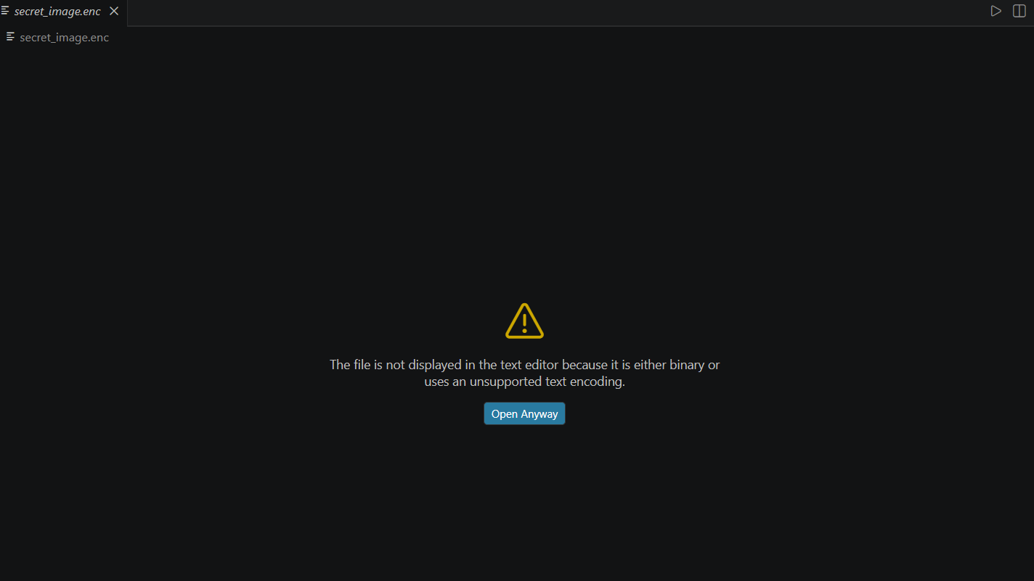
Giải mã ảnh
